武术简历- Martial Art Resume
石龙 - Gregory C. Brundage
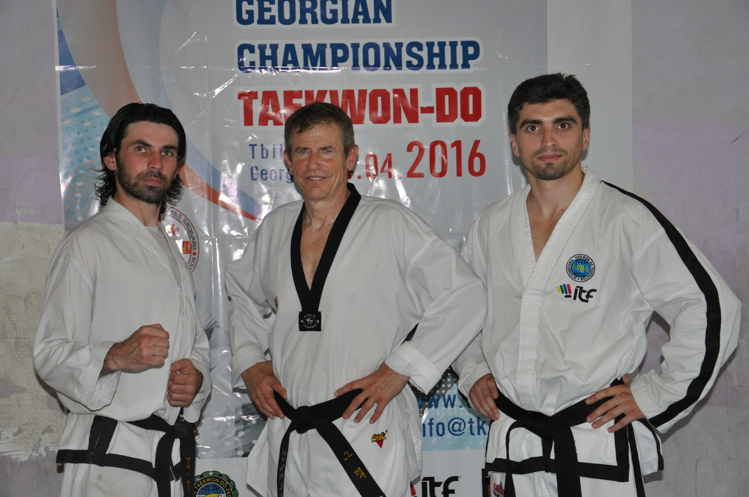
格雷戈里·布伦戴奇（Gregory Brundage）在中心 (2016)
在佐治亚州的丝绸之路

个人资料 PERSONAL DATA
国籍 Citizenship： 美国人USA, 但是我更喜欢人们认为我是
“负责任的世界公民”
住宅 Residence: 北京市昌平区 Beijing, Changping District
电子邮件e-mail: gregbrundage@live.com / director@silkroadresearchcenter.org
editor@silkroadvirtualuniversity.org
手机号码 Mobile: +86 186 1380 1327

武术训练MARTIAL ART EXPERIENCE
1969 * 开始柔道训练，密尔沃基市中心基督教青年会， 尼尔罗森博格4丹美国
* 开始（ITF） 跆拳道训练，密尔沃基市区青年会，李先生， 美国第6丹
1971 – 1980 在美国各地参加了200多次柔道比赛
1972, Summer 在西班牙巴塞罗那进行柔道训练Judo training in Barcelona, Spain
1972, Fall 由Guy Stowell教授的Hatha瑜伽和太极拳培训开始
Began Hatha Yoga & Tai Chi training taught by Guy Stowell
1973 金牌-州立中学柔道锦标赛Gold Medal - State High School Judo Championship
金牌-初级国家奥林匹克柔道和许多其他奖牌和奖杯美国
Gold Medal - Junior State Olympic Judo and numerous; many other medals and trophies USA
荣获第1次Kyu柔道棕色腰带USJA Awarded 1st Kyu Judo brown belt USJA
1973 在美国威斯康星州密尔沃基市开始在学校中培训“ Shorin-Ryu空手道”USA
1974 跆拳道俱乐部–南美洲哥伦比亚卡利Club Taekwondoka – Cali, Columbia, South America
1973-1976 中国武术/功夫培训，与西蒙·陈大师一起，以及 美国威斯康星州密尔沃基市大学俱乐部的Jimmy Young
Chinese Wushu/Kung Fu training, with Masters Simon Chen, and
Jimmy Young, University Club, Milwaukee, WI, USA
1977 - 1979 与世界冠军大师约翰·卡里尼（John Carini）第4丹（密尔沃基）一起开始高级跆拳道训练，
1980 – 1992 我曾在Kempo Goju 空手道学校担任空手道 “Sempai” 高级教练/培训师），教授大多数课程，除了高级先生的大师班，这是由Sensei，Mohamad Sabir，5th Dan，4813 W. Center St. Milwaukee WI USA教授的。
1981 晋升为第一丹黑带，肯坡高居空手道Promoted to 1st Dan Black Belt, Kempo Goju Karate
1982 晋升为第2丹黑带Kempo Goju空手道Promoted to 2nd Dan Kempo Goju Karate
1974-1988 参加了200多个空手道，跆拳道和武术功夫比赛Participated in 200+ Karate, Taekwondo & Wu Shu Kung Fu tournaments
1983-1988 击剑，专门从事各种比赛的美国重剑奖牌
Fencing, specializing in Epee USA Medals in various competitions
1992-1995 空手道-圣约翰学校，马来西亚吉隆坡国际空手道队培训, 马来西亚
Karate – St. John’s School, training with International Karate Team Kuala Lumpur, Malaysia
1994 泰拳踢拳，吉迪体育馆，曼谷，泰国，考山路Mui Thai Kick Boxing, Jeddi Gym, Bangkok, Thailand, Khaosan Road
1996-2002 参见美国威斯康星州密尔沃基的Goju空手道
Kempo Goju Karate, Milwaukee, WI USA
2002 移居韩国-跆拳道训练Moved to Korea - Taekwondo training
2003 晋升为韩国全州市第1丹黑腰带跆拳道
Promoted to 1st Dan Taekwondo, Jeonju, South Korea
2003-2008 剑道训练（韩国剑道）全州九段湾，与朴永春大师7丹·黑带
（韩国）Kendo Training (Korean Kendo) Jeonju Kumdogwan, with Master Park Yong Chun 7th Dan Black Belt, South Korea
2004 – 2009 晋升为韩国全州市跆拳道第2丹（黑带）
Promoted to 2nd Dan Taekwando, Jeonju, South Korea
2005 - 2009 “Kookung” –韩国传统射箭训练班，韩国吉龙市–我参加了很多比赛 “Kookung” – Korean Traditional Archery training, Gyeryong City, South Korea – I participated in many competitions
2005 - 2009 Hapkido培训，韩国论山市
2006 - 2009 混合武术（MMA）培训韩国–不同地点
Mixed Martial Arts (MMA) training South Korea – Various locations
2009 – 现在 中国武术，跆拳道和剑道在北京的许多地方以及横跨
丝绸之路和埃塞俄比亚（东非）的培训Chinese Wushu, Taekwondo and Kendo training at many locations in Beijing across the Silk Roads and Ethiopia (East Africa)
2012 - 现在 铁人三项训练和众多国际铁人三项比赛
(主要是奥林匹克距离和某些短跑距离）。 铁人三项是一种很好的“交叉训练”形式，适用于所有武术以及一般的健康和健身. Triathlon training and numerous international Triathlon competitions (mostly Olympic distance and some Sprint distance). Triathlon is an excellent form of “cross-training” for all martial arts and general health and fitness.

我的武术故事 My Martial Art Story

在我12岁开始接受武术的正式训练之前，我已经进行了数百次真实的搏斗。
I was in hundreds of real fights before I started formal training in martial arts at age 12.

为什么这么多打架？ 这是因为我父亲获得了巨额津贴，可以在欧洲大学旅行和教学。
Why so many fights? It’s because my father got big grants to travel and teach in European Universities.
所以我不得不去不同国家的学校。So I had to go to schools in different countries.

老实说，我从未在自己的生活中挑起过一场战斗。但是，由于我与众不同，男孩们一直希望：I can honestly say I never initiated a fight in my life. But, because I was different, boys always wanted to:
- 证明他们有多“坚韧” Prove how “tough” they were
- “测试”新男孩（我）“Test” the new boy (me)
- 3）享受一些“乐趣” Just have some “fun”

1963 - 因此，从六岁开始，我在英格兰剑桥进行了许多战斗。So, I had to fight a lot starting at age six in Cambridge England.

通常有四个或五个或六个男孩试图殴打我。 为什么？ 恶霸总是胆小鬼。Usually there were four, or five or six boys trying to beat me up. Why? Bullies are almost always cowards.

因此，我学会了如何与大男孩团伙作斗争。So, I learned how to fight, even against gangs.
我并非总是赢球，但我了解到，如果我尝试跑步，它们会抓住我，并更加击败我。
I didn’t always win, but I learned that if I tried to run they would catch me and beat me harder.
最好站起来战斗。 这样我可以赢得一些尊重。
It was better to stand and fight. That way I could earn some respect.
我学会了对付帮派的策略，这些策略通常（但并不总是）奏效。
I learned strategies for fighting gangs that usually (but not always) worked well.

早在1960年代初期，西方男孩就说：“只有女孩才能踢脚。”
Back in the early 1960s western boys said: “Only girls use kicks.”
但是我知道踢是阻止那些大男孩的唯一方法，因为他们的手臂比我的长。
But I had learned that kicking was the only way to stop those bigger boys because their arms were longer than mine.

在1966年和1967年之后，他们对使用脚踢的态度有所改变，原因是 绿色大黄蜂电视连续剧 Their attitudes about using kicks in a fight changed a bit after 1966 and 1967 because of Bruce Lee and the TV show “The Green Hornet.”

1969年，我的家人搬回美国。In 1969 my family moved back to the United States.
我首先去了一所私立学校。 在我离开美国期间，那所学校的男孩接受了西方拳击训练。
I first went to a private school. The boys at that school had trained in western boxing during my absence from the USA.
那是我第一次与训练有素的拳击手作战。 我当时12岁。
Those were the first times I ever fought trained boxers. I was 12 years old.

我讨厌的一件事是被人打在脸上。通常我父母在学校忽略“我的问题”，但这次我父亲听了我的话，给我报了柔道班。
One thing I hate is being punched in the face. Usually my parents ignored “my problems” at schools, but this time my father listened and enrolled me in a Judo class.

我喜欢它。不久我也开始上跆拳道课。柔道在近距离格斗中是很好的。跆拳道对我的踢腿有很大帮助。I loved it. Soon after I started going to a Taekwondo class also. Judo is great for in close fighting. Taekwondo helped my kicks a lot.

当时在我的城市里没有人教中国功夫。但在1973，我遇到了一些来自香港和台湾的中国学生。他们开了一家功夫俱乐部。所以我也开始了少林功夫，太极拳和其他很多风格的训练。
No one was teaching Chinese Kung Fu in my city at that time. But in 1973 I met some Chinese students from Hong Kong and Taiwan. They started a Kung FU club. So I also started training in Shaolin Kung Fu, Tai Chi, and many other styles.

在我少年时代末期和20多岁时，我参加了许多武术比赛。During my late teenage and university years I fought in a lot of tournaments.

我以前经常去舞厅和女孩子见面。好几次，女孩们和我一起离开，大酒鬼们来到停车场，开始和我打架。
I used to go to dance bars sometimes and met girls. Several times girls left with me and big drunk men came out to the parking lot and started fights against me.

有时候，女孩们选择我来保护她们，让她们远离那些不会让她们孤单的邪恶男人——跟踪者和其他恶霸。
Sometimes girls chose me to help protect them from evil men that would not leave them alone – stalkers and other bullies.
在我十几岁和二十几岁的时候，我搭便车去了很多其他城市参加比赛。有时这些比赛在纽约、芝加哥和洛杉矶的危险地区举行。但没人打扰我。
In my late teens and 20s I hitch-hiked to a lot of other cities for tournaments. Sometimes those tournaments were in dangerous areas in New York, Chicago and Los Angeles. But nobody bothered me.

为什么？我不骄傲也不害怕。我很自信，也很友好。我把比赛服放在一个旧袋子里。有时男人问我：你为什么在这里？我告诉他们真相。他们尊敬一个参加武术比赛的人。
Why? I was not proud or afraid. I was confident and friendly. I carried my competition uniform in an old bag. Sometimes men asked me: Why are you here? I told them the truth. They respected a person who travels for martial art competitions.

受过训练的战斗机可以通过走路的方式识别其他战斗机。和他们眼神接触。
Trained fighters can recognize another fighter by the way they walk, and their eye contact. I made a lot of friends and never had a problem.

当我在研究生院（1984-1988）时，我不得不停止武术比赛，
因为我一直都在工作和学习。 然后我结婚了。 因此，我的生活在某些方面更加和平。
When I was in Graduate School (1984-1988) I had to stop martial art competitions because I had to work and study all the time. Then I got married. So, my life was a little more peaceful in some ways.
真的，比起那些恶意散布谣言和流言蜚语的人，我更喜欢有人打我或踢我。所以，懦夫和恶霸总是试图攻击好人。这是我喜欢写作和学习法律的一个原因。
Really, I prefer someone try to punch and kick me than spread rumors and malicious gossip. So, cowards will always try to attack a good person. This is one reason I like writing and I studied law.
我认为所有的武术家都需要学习医学和法律。两者都以不同但非常重要的方式保护一个人。
All martial artists need to also study medicine and law I think. Both protect a person in different but very important ways.

1988年我成为了一名报社记者，因为一个好的记者可以保护无辜者免受欺负者的贪婪和傲慢。这是我一生的工作。这就是我喜欢做的，让我感觉很好。
In 1988 I became a newspaper reporter, because a good reporter can work to protect the innocent from the greed and arrogance of bullies. This is my life’s work. This is what I like to do and makes me feel good.

