My Chinese Herbal Medicine List

Compiler’s notes:
- At least since the time of Genghis Khan (or perhaps Alexander the Greek), European and Asian traditional medical systems have done a lot of mixing.
- I researched most of these herbs using different sources. Unfortunately I haven’t had time to fully research them all. Please do research before using anything. The best source for this is: http://www.ncbi.nlm.nih.gov/pubmed/
- In addition to that I have to add: Please consult a physician before taking any medicine. They can have interactive effects, or side effects.
- It is the belief of most Chinese doctors that herbs tend to be (much) safer than most western medicines. None-the-less time spent in consultation and study do pay for themselves in the long run.
- I am no doctor or expert on Chinese medicine. The research below is simply my hobby. It takes decades to become a master of this science and art.
- This is an ongoing work. I’ve started added traditional formulas at the end of this list, but mostly I use reference books so I haven’t added many.
~ ~ ~

艾叶 àiyè Artemisia vulgaris
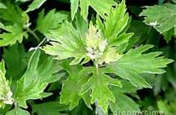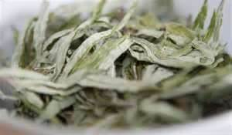

Mugwort promotes the appetite and proper digestion by its beneficial effect on bile production, and it acts as a mild purgative. A decoction is sometimes used to relieve pain, treat vaginal yeast infections, and regulate menstruation. It has also been used as a bath additive for gout, induces sweating, bronchitis, colds, colic, epilepsy, infertility, preventive for miscarriage, convulsions, hysteria, depression, mental exhaustion, insomnia, wounds, sores, boils, bruises, felons, kidney ailments, sciatica, rheumatism, stress, and tired legs. The fresh juice is helpful in relieving the itching of poison oak or poison ivy irritation, fungal infections, snakebite, insect bites, parasites and worms. A uterine stimulant, it helps in labor and delivery, plus helps expel the after-birth.
Mugwort stimulates the spinal cord and relieves congestion in the brain, a good brain tonic. Experimentally, it lowers blood sugar. Also known as sailor’s tobacco. In China this herb is most commonly used in moxibustion.

百合 Bǎi​hé​ Lily - Lilium lancifolium
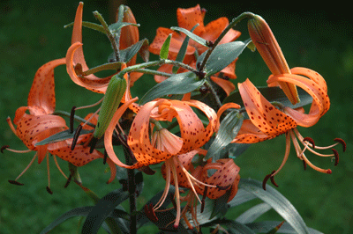
Sweet and cold in taste. 1. Moistening lung and relieving cough. 2.It can soothe the nerves. 3. It is used to cure insomnia.

白芍, 芍药 Bai Shao – (白芍药, 芍藥, 白芍藥) Adix Paeoniae Alba
Peony is used for gout, osteoarthritis, fever, respiratory tract illnesses, and cough. Women use peony for menstrual cramps, polycystic ovary syndrome, premenstrual syndrome (PMS), and for starting menstruation or causing an abortion. It is also used for viral hepatitis, liver cirrhosis, upset stomach, muscle cramps, “hardening of the arteries” (atherosclerosis), and to cause vomiting. Peony is also used for spasms, whooping cough (pertussis), epilepsy, nerve pain (neuralgia), migraine headache, and chronic fatigue syndrome (CFS).

薄荷 Bòhé - Mentha haplocalyx – Mint
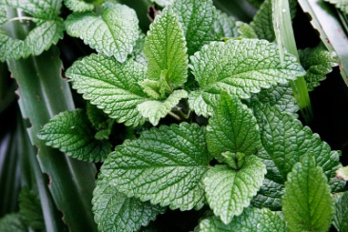
Therapudic effect: Digestive aide, bronchial dilator, mild sedative, nerve tonic, stimulant, decongestant, vasodilator, analgesic. Indications: headaches, cough, sore throat, sinus, dysmenorrheal, indigestion; , topically applied is antispasmodic, Dose: decoction 2-4 grams in empty stomach, powder or infusion or mix powder with lotion, oil or Vaseline for topical application.

苍术属 Cāngzhú shǔ - (Similar to) 白术 Báizhú –
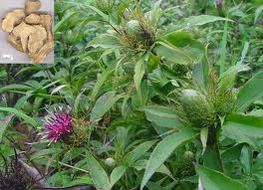
Atractylodes Chinensis (Thistle type) Rhizoma Atractylodes - Muscle growth, endurance, diarrhea, bloating, abdominal pain, vomiting and fatigue, anti-cancer, build qi/immune system, longevity, antiemetic, gastritis, muscle and joint pain. Dose: two or three doses of powder. In capsules of 5 – 10 grams on empty stomach. The medicine is distinguished from bái zhú (白术 or 白朮, white atractylodes rhizome from Atractylodes macrocephala), which is typically cultivated, whereas cāng zhú more often tends to be collected from the wild. It is believed that the distinction between cāng zhú and bái zhú emerged in relatively modern times; a single drug "zhú" described in the Shen nong ben cao jing probably included many Atractylodes species.

川芎 Chuānxiōng Rhizome of chuanxiong (Ligusticum wallichii); Also “芎”xiōnɡqiónɡ Chuanxiong (scientific name: Ligusticum chuanxiong hort), is a traditional Chinese medicine plant , commonly used in the blood circulation of qi, chills and pain, extensive stasis effect, suitable for a variety of blood stasis disease; chills and pain, the utility is very good and can cure head wind, headache, rheumatism embolism.

大料 Dàliào; 大茴香 Dàhuíxiāng - Anise Pimpinella anisum
Star anise has been used in a tea as a traditional remedy for rheumatism, assist in relieving cold-stagnation in the middle jiao, according to Traditional Chinese medicine. Star anise is the major source of the chemical compound shikimic acid, a primary precursor in the pharmaceutical synthesis of anti-influenza drug Oseltamivr (Tamiflu). Decongestant, cough, colds, due to mild antibacterial antiseptic properties: sore throat.

当归, 當歸 Dāngguī Radix Angelicae Sinensis
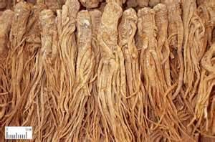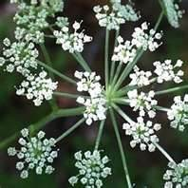
Dang gui also called Chinese angelica, dong quai, and tang kuei, is highly respected in Traditional Chinese Medicine, second only to ginseng. It is commonly used to treat women’s reproductive health issues, but is also recommended to help prevent and treat some forms of cardiovascular disease.

It is indicated for all kinds of pain syndromes caused by blood deficiency, blood stasis and congealing cold with blood stasis because it can tonify blood, activate blood, dispel cold and alleviate pain. It is an essential herb in gynecology and indicated for irregular menstruation, amenorrhea and dysmenorrhea because it can tonify blood, activate blood, regulate menstruation and alleviate pain.
Dang gui is one of many species of the herb angelica; other well-known species include Japanese angelica (A. acutiloba), European angelica (A. archangelica), and American angelica (A. atropurpurea). Each type of angelica is traditionally used to treat different disorders; for instance, European angelica is often used to treat inflammation, and American angelica is said to be good for indigestion. Chinese and Japanese angelica are the varieties that have been used historically to treat women’s health disorders, and these two types of angelica have been more widely researched than any of the other species.
Dang gui roots contain phytoestrogens, which are chemicals found in plants that mimic the effects of estrogen in the body. Dang gui is said to help balance women’s hormone levels, both restraining and supplementing the body’s production of estrogen as needed. It is used to treat menstrual and menopausal symptoms, including migraine, cramps, mood fluctuations, and hot flashes. It is also said to help speed a woman’s recovery from childbirth and symptoms of low energy/chronic fatigue.
Dang gui helps relax the smooth muscles throughout the body, which makes it a potential treatment for a variety of illnesses. Not only does dang gui relax the smooth muscles of the uterus, but it also keeps the smooth muscles in the arteries dilated, helping to maintain regular blood flow and heartbeat. Dang gui has been used to treat angina, high blood pressure, and irregular heartbeat. Some studies have shown that the antispasmodic, dilating effects of dang gui may help treat chronic pulmonary hypertension in people with chronic obstructive pulmonary disease (COPD), especially when taken in combination with the drug nifedipine.
Dang gui contains phytochemicals that help boost white blood cell production and fight inflammation, and may improve liver and kidney function. It is traditionally used to treat inflammatory diseases such as arthritis, and is currently being studied for its ability to prevent or treat cancer, liver and kidney disease.
Only the root of the dang gui plant is used medicinally. It is usually dried and ground to make the teas, capsules, tablets, tinctures, and other combination products available at most health food stores.
Counter indications: Pregnant women should not take this herb because it may encourage menstruation. Dang gui is also known to cause diarrhea in some people, so those with gastrointestinal difficulties should also avoid this medication. People that are taking blood thinners should consult a doctor before trying dang gui—it may increase the effects of these drugs.
丹参 Dān​shēn​ - Salvia Root, Salvia Miltiorrhiza;
Labiatae/Lamiaceae family - Properties: BITTER - COOL
Orally, Danshen is used for circulation problems, ischemic stroke, angina pectoris, and other cardiovascular diseases. It is also used orally for menstrual problems, chronic hepatitis, abdominal masses, insomnia due to palpitations and tight chest, acne, psoriasis, eczema, and other skin conditions. Danshen is also used orally to relieve bruising and to aid in wound healing.

熟地黄 (Shu) Dìhuáng (地黄) or gān dìhuáng (干地黄) (R. glutinosa) is used as a medicinal herb for arthritic conditions within Chinese traditional formulations. Rehmannia contains the vitamins A, B, C, and D,[citation needed] as well as other compounds, such as catalpol, an iridoid glycoside, that has been shown to exert protective effects on dopaminergic neurons in aged rats to help inhibit microglial activation, thereby reducing the production of pro-inflammatory factors.

独活 Dúhuó - Angelica dried roots. (Other names: Du Huo Ji Sheng Tang, Du Huo Ji Shang, Du Huo Ji Sheng Wan, Duhuojishengwan, Guang Ci Tang, Plum Flower - Mainly produced in Sichuan, Hubei, Anhui and other places. rheumatism, bipedal Tong Bi, wet itch Spasm." Modern research, independent living has anti-inflammatory, analgesic and sedative effect; inhibition of platelet aggregation; and a hypotensive effect, but not durable; lactones are perfumed citrus, pepper and toxins, which are sensitive and anti-tumor effect. Some laboratory studies have shown that Duhuo Jisheng Wan can clear inflammation by activating specific anti-inflammatory cells in your body. The International Agency for Research on Cancer has classified herbal products which include the Aristolochia plant (which contain a high level of of aristolochic acid) as carcinogenic (causes cancer) to humans. They’ve also been linked to kidney damage. - See more at: http://www.arthritisresearchuk.org/arthritis-information/complementary-and-alternative-medicines/cam-report/complementary-medicines-for-osteoarthritis/djw.aspx#sthash.zO9TZmEE.dpuf
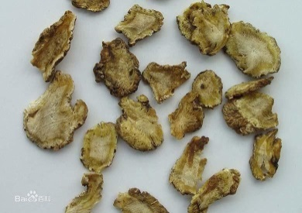 Duhuo

杜仲 Dù zhòng（植物滋补药材）Dù zhòng - Eucommia ulmoides Oliver
Dried bark , is a Chinese precious tonic herb. It is sweet and warms the liver, kidney and stomach. It is known for efficacy and kidney tonic, sinews and bones, conditioning Chong and Ren, helpful after miscarriage. Treatment deficiency caused by low back pain or other joint weakness. It is classified in “Shen Nong's Herbal Classic” as a top grade herbal medicine.

防风草 Fángfēngcǎo (“Windproof”) RADIX Saposhnikoviae; (and/or) Radix ledebouriellae Divaricatae; relieving chills, wins wet, antispasmodic. For colds, headache, rheumatism, rubella itching, tetanus.

茯苓 Fuling Poria
It can induce diuresis and drain dampness to eliminate the pathogens, and invigorate spleen to reinforce healthy. Its property is mild, tonic but not stagnant, and diuretic without consumption. It is an essential herb for inducing diuresis and alleviating edema. For various edema no mater cold, heat, deficiency or excess types, it is usually combined with Zhu Ling to mutually promote the effect of inducing diuresis and draining dampness. And the combination with other herbs depends on differentiation. For edema and dysuria due to water-damp retention, it is usually combined with Zhu Ling, Ze Xie, Bai Zhu, Gui Zhi such as in Wu Ling San from Shang Han Lun.

甘草 Gān​cǎo - Licorice

​This is probably the most commonly used root in Chinese medicine. Catalyst for other herbs, expectorant, emollient to stomach ulcers, antidote, tonic, antipyretic, laxative, sedative, antitussive(fever), lowers cholesterol and blood sugar, inhibits tumors, good for colds, fever, sore throat, bronchitis, gastritis, alcohol and drug poison, hepatitis, cirrhosis, skin rash, deficient blood & energy. Dose: Decoction 2-8 grams in two doses on empty stomach. For colds add ginger. In herbalism it is used in the Hoxsey anti-cancer formula, and is a considered adaptogen which helps reregulate the hypothalamic-pituitary-adrenal axis. It can also be used for auto-immune conditions including lupus, scleroderma, rheumatoid arthritis and animal dander allergies. Glycyrrhizin from Glycyrrhiza root has been shown to modulate airway constriction, lung inflammation and infiltration of eosinophils in bronchial areas by stimulating CD4 and CD8 immune cell function. Liquorice may be useful in conventional and naturopathic medicine for both mouth ulcers and peptic ulcers

活血丹 Huóxuèdān Glechoma Longituba (Used by Shaolin)
Currently researching

桂枝 Guìzhī Cinnamomum Cassia Presl
Its spicy, sweet, warm, lungs, heart, bladder, is attending in cold temperatures where conventional medicine with complementary Yuanyang, blood, warm stomach effect, often associated with liver or kidney medicine, qi and blood drug compatibility, treat kidney deficiency, Vital Huoshuai, cold extremities pulse, and the drug combination on abdominal Leng Tong, Bi lumbago other warm in the cold, with a significant role in the analgesic and anti-cancer.

红花 Hónghuā AiCao Carthamus tinctorius
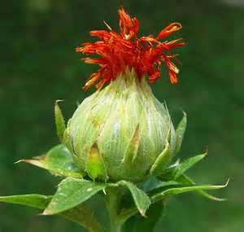
Activate blood and dredge meridians, dispel stasis and alleviate pain, amenorrhea due to stasis, dysmenorrhea, postpartum abdominal pain. It is a commonly used herb in treating blood stasis in gynecology and obstetrics. It is used singly or combined with blood-activating and nourishing and meridian-dredging herbs such as Dang Gui, Chuan Xiong and Tao Ren.

黄精 Huángjīng - Solomon’s Seal Sealwort
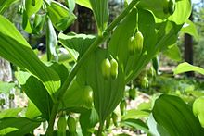
Kidneys, spleen, tonic, nutrient, emulcent (soothing), sedative, cooling, digestive, stim. appetite, aphrodisiac, broken bones, ulcers. Dose: Decoction 6-10 grams, two doses on empty stomach. Traditionally, Solomon's Seal purportedly alleviates a range of afflictions from menopause to broken bones. As a topical application, the root are said to expedite the healing of cuts and bruises, skin irritations and inflammations, and as a face wash is good for acne, blemishes and all kinds of imperfections of the skin. Its use to fight diabetes was first observed in 1930 by Hedwig Langecker. After experiments, she concluded that it was effective in fighting nutritional hyperglycemia, though not that caused by adrenaline release, probably due to its content of glucokinin

胡芦巴 Húlúbā - Fenugreek - Trigonella foenumgraecu
A June 2011 study at the Australian Centre for Integrative Clinical and Molecular Medicine found that men aged 25 to 52 who took a fenugreek extract twice daily for six weeks scored 25% higher on tests gauging libido levels than those who took a placebo. Texas A&M University to determine if fenugreek benefits testosterone levels and availability. Each day of the study, 30 male subjects were either given 500 mg of fenugreek or a placebo. During the study, subjects who received fenugreek had a 6.57% increase in total testosterone and a 12.26% increase in “free” testosterone.

黄根 - Jiānghuánggēn – Tumeric Used to eliminate blood stasis, promote the flow of qi, stimulate menstrual discharge, and relieve pain. Indications: pricking pain in the chest and hypochondriac regions; amenorrhea; mass formation in the abdomen; rheumatic pain of the shoulders and arms; traumatic swelling and pain.
Curcuma 郁金根 yùjīngēn – UJIN yujin contains tolylmethylcarbinol, which is a cholegogue (causes the gall bladder to contract and spill bile into the intestines) that is present in only trace amounts in turmeric. Because of the action of this active constituent, yujin—but not turmeric—is mentioned in some Chinese texts as treating gallbladder congestion (which may further explain its actions of resolving phlegm accumulation and clearing heat, two results of proper gallbladder function).
These two herbs are often confused. Regarding confusion in naming of the above two herbs see very interesting article: http://www.itmonline.org/arts/turmeri3.htm

决明子 Juémíngzǐ Cassia seed

Removes heat, improve eyesight, relaxes bowels, reduce blood pressure. Called “slimming tea”

马鞭草 Mǎbiāncǎo Verbena officinalis
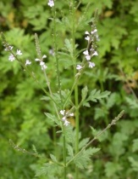
Analgesic, antitumor, astringent, anticoagulant, antibacterial, antispasmodic, diaphoretic, depurative, diuretic, vulnerary, tonic and stimulant, insomnia and “daytime illness,” post-natal depression and irregular menstruation as well as increases flow of breast milk. Consuming the plant extracts relaxes the muscles and helps in sleeping. This plant is also used to cure snakebites. It heals respiration problems like asthma and whooping cough. CONTRAINDICATIONS: Not to consume during pregnancy however facilitates the contraction of uterine muscles during labor.

柠檬草 Níngméngcǎo Lemon grass Cymbopogon citratus

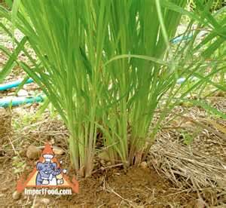
Lemon grass as herbal medicine with antifungal, anti-bacterial properties, helps gastro-intestinal problems, stomachaches, diarrhea, gas, bowel spasms, vomiting, fever, the flu, and headaches, and infectious illnesses. Lemon grass is also used in Chinese medicine to treat colds and rheumatism, antiseptic, suitable for use on various types of skin infections, usually as a wash or compress, and is especially effective on ringworm, infected sores, acne and athlete's foot . Lemongrass may be effective in killing cancer cells. Insect repellent but attracts bees!

牛膝 Niúxī - 怀牛膝 Huai Niu Xi Achyranthes bidentata root

In TCM, Huai Niu Xi:
1: Invigorates the Blood, Expels Blood Stasis.
2: Strengthens Sinews and Bones, Benefits the Joints.
3: Clears Damp Heat in the Lower Burner.
4: Induces the Downward Movement of Blood.

牵牛 Qiān​niú - Morning Glory ​( Blue)
Shortness of breath, constipation, intestinal parasites, swelling. Effects enhanced when used with Costus and ginger. Do not take if pregnant. Dose: Decoction: 1-3 grams, in two doses on empty stomach. (Caution – some variety of this plant can act as a hallucinogenic)

芡实 Qiànshí - Foxnut, Euryale Ferox
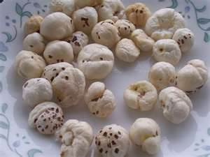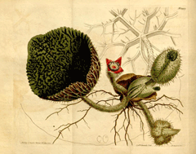
A gorgon fruit; a semen euryales; a gorgon euryale seed, can be used to make starch; also 鸡头米 (ji tou); a large aquatic plant of water lily family, seeds are oval contain 10% protein and starch. Therapeudic Effect: Tonic, nutrient; astringent, analgesic, regulates blood pressure, tonifies kidney, Indications: neuralgia, neuritis, arthritis, premature aging; Dose: decoctions: 10 – 20 grams in 3 doses or powder 9-15 grams on empty stomach.

秦艽 Qínjiāo Radix Gentianae Macrophyllae, Qinjiao – Radix Gentianai Macrophyllae
Being pungent and bitter with the actions of dispersing and discharging, slightly cold without dryness, it excels in dispelling wind-damp, unblocking collaterals to alleviate arthralgia, and can be used with compatibility in treating all kinds of arthralgia syndromes due to wind and dampness, spasm of tendons and vessels and aching pain of scleromere no matter what disease condition is in, such as cold, hot, acute or chronic. Because of the predominant cold nature and the actions of clearing damp-heat, it is more suitable for heat arthralgia manifested by red swelling and burning pain of joints, and often combined with wind-damp-dispelling herbs and heat-clearing herbs…

人参 Rén​shēn - Ginseng
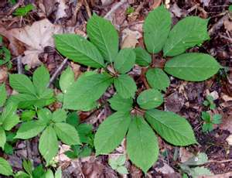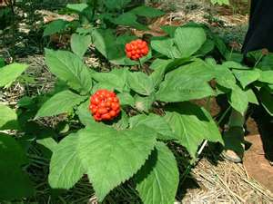
Ginseng ​Tonic, stimulant, aphrodisiac, immune booster, panacea and restorative, liver and lungs, good for exhaustion, lack of appetite, short term memory. Dose: Decoction 5-10 grams for 30-60 minutes, one dose on empty stomach in morning

肉桂 Ròu​guì​ - Cinnamon
Stimulant, analgesic, loss of appetite, stimulates digestion, fatigue, abdominal pain, lack of energy, red or swollen eyes, cold extremities. When used with ginseng and licorice, treatment for headache too Dose: Decoction: 2-5 grams in two doses on empty stomach. Later can be chewed.

菟丝子 Tú sī zǐ - Dodder, love vine, field dodder
Also called Yunu (jade woman 玉女) & Yeh hu sse, wild fox silk – a parasitic herb. Medicinal seeds are brown; contain glycoside cuscutin, reproductive tonics and longevity formulas improves vision, urinary tract, kidney, lumbago, senility. Dose: decoction: 7-12 grams in two doses; Contraindications: do not use with open sores. Complimentary with Chinese yam for longevity, it’s non-toxic and can be used long-term.

山楂 Shānzhā - Hawthorn - Mayflower
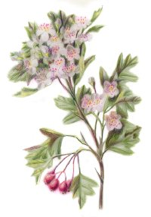
Member of rose family- has substantial vitamin C. Therapeutic effect: Cardiotonic, flavonoids -- anthocyanidins and proanthocyanidins -- which reduce blood vessel sensitivity to and damage from oxidizing agents, improves the integrity of veins and arteries, enhancing circulation and nutrition to the heart. This action makes it useful for cases of angina, atherosclerosis, weakness and enlargement of the heart, high and low blood pressure, and elevated cholesterol levels. (Reverence for the hawthorn in Europe is an ancient tradition. The ancient European druids included the hawthorn with the sacred oak and the ash in a trio of trees with special powers. Dose: Decoction: 4-6 grams twice daily.

吴茱萸属 Wúzhūyú shǔ - Evodia
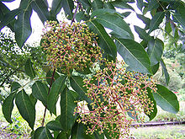
Headache, cold hands and feet, loss of appetite, nausea, tension. Headache Dose: Two decoctions morning and night on empty stomach: Evodia 3 grams, Ginseng 2 grams, Jujube 4 grams, ginger 4 grams

细辛 Xì xīn – Herba Asari - Asarum
Relieving cold, chills and pain, Tongqiao, WHR. For cold cold, headache, toothache, nasal congestion, runny nose, allergic rhinitis, Biyuan, Fengshibitong, phlegm cough. Asarum as medicinal plants, only contained in the Qin and Han "Shen Nong's Herbal Classic", "Shen Nong's Herbal Classic" will be listed as the top grade. Liao Asarum root thin, sallow color, dark green, spicy flavor Ma tongue. Warm, a small drug. Heart, lung, kidney. There are chills, cold, warm the lung, the role of the water line, resuscitation. Governance cold, headache, Biyuan, tooth pain, phlegm Keni, Fengshibitong. In addition, Asarum also has anti-inflammatory immune, local anesthesia, increase metabolism, antibacterial effect, can be used for patients with cancer of white blood cells caused by chemotherapy and radiotherapy reduced.

野菊花 Yějúhuā Chrysanthemum
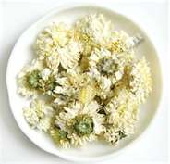
Chrysanthemum tea has many purported medicinal uses, including an aid in recovery from influenza, acne and as a "cooling" herb. According to traditional Chinese medicine the tea can aid in the prevention of sore throat and promote the reduction of fever. In Korea, it is known well for its medicinal use for making people more alert and is often used as a pick-me-up to render the drinker more awake. In western herbal medicine, Chrysanthemum tea is drunk or used as a compress to treat circulatory disorders such as varicose veins and atherosclerosis. In traditional Chinese medicine, chrysanthemum tea is also said to clear the liver and the eyes. It is believed to be effective in treating eye pain associated with stress or yin/fluid deficiency. It is also used to treat blurring, spots in front of the eyes, diminished vision, and dizziness. The liver is associated with the element Wood which rules the eyes and is associated with anger, stress, and related emotions.

野生苦丁茶 Yě​shēng​ kǔ​Dīng​ – Wild Bitter Tea

Effects: Calm, hypertension, reduce blood pressure, maintain good weight, cool the body, reduce irritation in eyes and nose (during a cold or allergy), improve memory and mental focus, clear the lungs of phlegm. Dose and Prep: Infuse 1 tsp in 500ml of hot but not boiling water. The perfect temperature is around 85 degrees If you brew in boiling water the infusion will start to taste bitter. Ideally use filtered water. Li's (李时珍) "Compendium of Materia Medica" (本草纲目) records and Kuding cha bitter leaf, nature, .... thirst quencher, eyesight, Chufan, phlegm, diuresis, through the small intestine, governance cream, headache, detoxification, anti-inflammatory.

银杏 Yín​xìng​ (Kernels) Gingko Biloba
Sedative, cardio-tonic, digestive, antidote to alcohol, nourishes kidney, warms lung energy. Good for asthma, cough, bladder infections. Dose: 5 to 15 grams in capsule three times a day after eating; caution, can be toxic in large doses. When eaten in large quantities or over a long period, especially by children the gametophyte (meat) of the seed can cause poisoning by MPN (4'-O-methylpyridoxine. MPN is heat stable and not destroyed by cooking. Studies have demonstrated that convulsions caused by MPN can be prevented or terminated with pyridoxine.

银杏 Yín​xìng (Root) Gingko Root
Good for kidneys and nocturnal emission. Dose: 10 – 15 grams in two doses on empty stomach

銀杏叶子 Yín Xìng (Leaves) Gingko Leaves
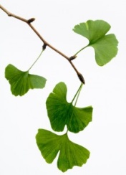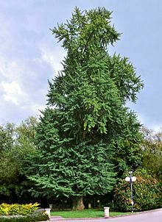
Ginkgo is mainly used as memory and concentration enhancer, and anti-vertigo agent. Ginkgo extract may have three effects on the human body: improvement in blood flow (including microcirculation in small capillaries) to most tissues and organs; protection against oxidative cell damage from free radicals; and blockage of many of the effects of platelet-activating factor (platelet aggregation, blood clotting) that have been related to the development of a number of cardiovascular, renal, respiratory and central nervous system disorders.

This is an absolutely fascinating tree. One source I read claimed it is the oldest living species of tree. Kind of makes sense it might enhance memory.

枣 Zǎo - Jujube (Ziziphus Vulgaris)
Tonic, nutrient, sedative, emollient to lungs, secretions of vital fluids, tonifies spleen and stomach… Good for fatigue, insomnia, hypertension, retards aging… Dose: Decoction 6-12 fruits, with crushed kernels

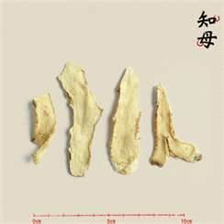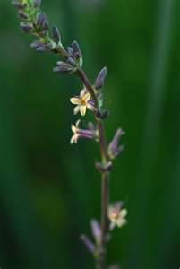

草乌 Zhicaowu - Radic Aconiti Kusnezoffii Preparata – Primarily an analgesic
Roots also known as Aconitum head (English name: Kusnezoff Monkshood Root), toxic medicine can treat rheumatism, and cold pain. Aconitum genus of about 350 species of plants, located in the north temperate zone, there are 165 kinds of Chinese, about 36 kinds for medicinal purposes.
This is a powerful drug – compared with morphine. Useful for: Liver, spleen, rheumatism, cold pain, swelling. Governance wind musculoskeletal joint pain, stroke paralysis, tetanus, chronic headache, abdominal pain, gas block.
Decoction with Kusnezoffii 1.5-6 grams, should fry for 1 hour or longer. Helpful for swelling from gangrene and poison. Sward transfer deposited into powder, should not be used on broken skin. Excessive or improper oral decoction, prone to cause poisoning. Not advised for pregnant women, avoid eye contact. Can cause heart rhythm disorders, and even ventricular fibrillation. Aconitum head still local anesthetic effect.

制川乌拼音名 Zhichuanwu (Potentially dangerous)
For wind musculoskeletal, joint pain, confidants Leng Tong, Han Shan ached, narcotic pain.
Dosage 1.5 ~ 3g. Should fry, fry a long time.

知母 Zhīmǔ - Anemarrhena asphodeloides – Wind-weed
Contains saponin asphonin with antipyretic properties, and mucilage. Emollient to bowels, useful for night sweats, erectile dysfunction due to adrenal insufficiency, insomnia, diarrhea, constipation, pneumonia and bronchitis. DOSE: Decoction 6 – 12 grams two doses or powder 5 – 10 grams. Contraindications: prolonged use can cause chronic loose bowels. Incompatibles: Iron preparations; iron utensils

-----------
FORMULAS
-------

Herbal Therapy Decoction for: degenerative arthritis, degenerative joint disease or osteoarthritis

Source: Traumatology and Orthopedics of Traditional Chinese Medicine; A Newly complied Practical English-Chinese Library of Traditional Chinese Medicine. Examiner in Chief: Zhu Fangshou, Compiler in Chief: Huang Guicheng, Translator in Chief: Zhang Qingrong, Shanghai Pujian Educational Press, Shanghai University Of Traditional Medicine Press – Complied by Nanjing University of Treaditional Chinese Medicine; Translated by Shanghai University of Traditional Chinese Medicine, 2002. 2011, July

Modified 独活 Dúhuó Decoction - alleviate pains due to Wind and Dampness. Today it is used for rheumatic arthritis, rheumatoid arthritis, rheumatic back pain, sciatica, etc
独活 Dúhuó 6 - gms. (British research suggests this herb is a possible carcinogen)
防风草 Fángfēngcǎo – 6 gms.
川芎 Chuānxiōng - 6 gms.
桂枝 Guìzhī – 6 gms.
牛膝编辑 Niú xī - 6 gms
白芍, 芍药 Bai Shao – 10 gms.
秦艽 Qínjiāo – 10 gms.
当归, 當歸 Dāngguī – 10 gms
茯苓 Fuling - 10 gms
杜仲 Dù zhòng – 12 gms
细辛 Xì xīn 3 gms.
熟地黄 (Shu) Dìhuáng – 15 Gms.
甘草 Gancao - 3 gms
草乌 Zhicaowu (Potentially very dangerous- heart arrhythmia; must be prepared correctly, Fry for one hour) 4 Gms.
制川乌拼音名 Zhichuanwu (Potentially very dangerous- heart arrhythmia; must be prepared correctly, Fry for one hour) 4 Gms.

DESCRIPTIONS (Same as on above list – but need to be considered carefully)

独活 Dúhuó - Angelica dried roots. (Other names: Du Huo Ji Sheng Tang, Du Huo Ji Shang, Du Huo Ji Sheng Wan, Duhuojishengwan, Guang Ci Tang, Plum Flower - Mainly produced in Sichuan, Hubei, Anhui and other places. rheumatism, bipedal Tong Bi, wet itch Spasm." Modern research, independent living has anti-inflammatory, analgesic and sedative effect; inhibition of platelet aggregation; and a hypotensive effect, but not durable; lactones are perfumed citrus, pepper and toxins, which are sensitive and anti-tumor effect. Some laboratory studies have shown that Duhuo Jisheng Wan can clear inflammation by activating specific anti-inflammatory cells in your body. The International Agency for Research on Cancer has classified herbal products which include the Aristolochia plant (which contain a high level of of aristolochic acid) as carcinogenic (causes cancer) to humans. They’ve also been linked to kidney damage. - See more at: http://www.arthritisresearchuk.org/arthritis-information/complementary-and-alternative-medicines/cam-report/complementary-medicines-for-osteoarthritis/djw.aspx#sthash.zO9TZmEE.dpuf
Duhuo

防风草 Fángfēngcǎo (“Windproof”) RADIX Saposhnikoviae; (and/or) Radix ledebouriellae Divaricatae; relieving chills, wins wet, antispasmodic. For colds, headache, rheumatism, rubella itching, tetanus.

川芎 Chuānxiōng Rhizome of chuanxiong (Ligusticum wallichii); Also “芎”xiōnɡqiónɡChuanxiong (scientific name: Ligusticum chuanxiong hort), is a traditional Chinese medicine plant , commonly used in the blood circulation of qi, chills and pain, Chuan Xiong Xin Wen Hong dry, keep walking instead, both lines scattered, upstream up to top of the roof; and into the blood, Downstream up to a sea of blood. Extensive stasis effect, suitable for a variety of blood stasis disease; chills and pain, the utility is very good and can cure head wind, headache, rheumatism embolism.

桂枝 Guìzhī Cinnamomum Cassia Presl) Its spicy, sweet, warm, lungs, heart, bladder, is attending in cold temperatures where conventional medicine with complementary Yuanyang, blood, warm stomach effect, often associated with liver or kidney medicine, qi and blood drug compatibility, treat kidney deficiency, Vital Huoshuai, cold extremities pulse, and the drug combination on abdominal Leng Tong, Bi lumbago other warm in the cold, with a significant role in the analgesic and anti-cancer.

牛膝编辑 Niú xī Roots contain saponin, and with ecdysterone and inokosterone , medicine there is stasis pass through, liver and kidney, strong bones, diuretic Tonglin and other effects. promoting blood circulation; treatment of postpartum abdominal pain, irregular menstruation, amenorrhea, epistaxis
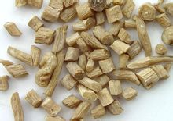
False fire toothache, beriberi edema; familiar with, liver and kidney, strong waist and knee; governance waist and knee pain, liver and kidney deficiency, bone pain stasis. Veterinary treatment of cattle used for soft foot disease, falls and other broken bones.

白芍, 芍药 Bai Shao – (白芍药, 芍藥, 白芍藥) Adix Paeoniae Alba
Peony is used for gout, osteoarthritis, fever, respiratory tract illnesses, and cough. Women use peony for menstrual cramps, polycystic ovary syndrome, premenstrual syndrome (PMS), and for starting menstruation or causing an abortion. It is also used for viral hepatitis, liver cirrhosis, upset stomach, muscle cramps, “hardening of the arteries” (atherosclerosis), and to cause vomiting. Peony is also used for spasms, whooping cough (pertussis), epilepsy, nerve pain (neuralgia), migraine headache, and chronic fatigue syndrome (CFS).

秦艽 Qínjiāo Radix Gentianae Macrophyllae, Qinjiao – Radix Gentianai Macrophyllae
Being pungent and bitter with the actions of dispersing and discharging, slightly cold without dryness, it excels in dispelling wind-damp, unblocking collaterals to alleviate arthralgia, and can be used with compatibility in treating all kinds of arthralgia syndromes due to wind and dampness, spasm of tendons and vessels and aching pain of scleromere no matter what disease condition is in, such as cold, hot, acute or chronic. Because of the predominant cold nature and the actions of clearing damp-heat, it is more suitable for heat arthralgia manifested by red swelling and burning pain of joints, and often combined with wind-damp-dispelling herbs and heat-clearing herbs…

当归, 當歸 Dāngguī Radix Angelicae Sinensis
It is indicated for all kinds of pain syndromes caused by blood deficiency, blood stasis and congealing cold with blood stasis because it can tonify blood, activate blood, dispel cold and alleviate pain. It is an essential herb in gynecology and indicated for irregular menstruation, amenorrhea and dysmenorrhea because it can tonify blood, activate blood, regulate menstruation and alleviate pain.

茯苓 Fuling Poria
It can induce diuresis and drain dampness to eliminate the pathogens, and invigorate spleen to reinforce healthy. Its property is mild, tonic but not stagnant, and diuretic without consumption. It is an essential herb for inducing diuresis and alleviating edema. For various edema no mater cold, heat, deficiency or excess types, it is usually combined with Zhu Ling to mutually promote the effect of inducing diuresis and draining dampness. And the combination with other herbs depends on differentiation. For edema and dysuria due to water-damp retention, it is usually combined with Zhu Ling, Ze Xie, Bai Zhu, Gui Zhi such as in Wu Ling San from Shang Han Lun.

杜仲 Dù zhòng（植物滋补药材）Dù zhòng - Eucommia ulmoides Oliver
Dried bark , is a Chinese precious tonic herb. It is sweet and warms the liver, kidney and stomach. It is known for efficacy and kidney tonic, sinews and bones, conditioning Chong and Ren, helpful after miscarriage. Treatment deficiency caused by low back pain or other joint weakness. It is classified in “Shen Nong's Herbal Classic” as a top grade herbal medicine.

熟地黄 (Shu) Dìhuáng (地黄) or gān dìhuáng (干地黄) (R. glutinosa) is used as a medicinal herb for arthritic conditions within Chinese traditional formulations. Rehmannia contains the vitamins A, B, C, and D,[citation needed] as well as other compounds, such as catalpol, an iridoid glycoside, that has been shown to exert protective effects on dopaminergic neurons in aged rats to help inhibit microglial activation, thereby reducing the production of pro-inflammatory factors.

细辛 Xì xīn – Herba Asari - Asarum
Relieving cold, chills and pain, Tongqiao, WHR. For cold cold, headache, toothache, nasal congestion, runny nose, allergic rhinitis, Biyuan, Fengshibitong, phlegm cough. Asarum as medicinal plants, only contained in the Qin and Han "Shen Nong's Herbal Classic", "Shen Nong's Herbal Classic" will be listed as the top grade. Liao Asarum root thin, sallow color, dark green, spicy flavor Ma tongue. Warm, a small drug. Heart, lung, kidney. There are chills, cold, warm the lung, the role of the water line, resuscitation. Governance cold, headache, Biyuan, tooth pain, phlegm Keni, Fengshibitong. In addition, Asarum also has anti-inflammatory immune, local anesthesia, increase metabolism, antibacterial effect, can be used for patients with cancer of white blood cells caused by chemotherapy and radiotherapy reduced.

甘草 Gancao - Liquorish - Radix Glycyrrhizae
Tonify qi of heart and spleen, dispel phlegm, relieve cough and dyspnea, relieve spasm and pain, clear heat and relieve toxicity, and harmonize property of medicine. This is probably the safest and most commonly used of Chinese medicine. It is also often added as a catalyst to facilitate integration of other combinations of herbal medicines.

For severe knee pain the following may be added:
草乌 Zhicaowu - Radic Aconiti Kusnezoffii Preparata – Primarily an analgesic
Roots also known as Aconitum head (English name: Kusnezoff Monkshood Root), toxic medicine can treat rheumatism, and cold pain. Aconitum genus of about 350 species of plants, located in the north temperate zone, there are 165 kinds of Chinese, about 36 kinds for medicinal purposes.
This is a powerful drug – compared with morphine. Useful for: Liver, spleen, rheumatism, cold pain, swelling. Governance wind musculoskeletal joint pain, stroke paralysis, tetanus, chronic headache, abdominal pain, gas block.
Decoction with Kusnezoffii 1.5-6 grams, should fry for 1 hour or longer. Helpful for swelling from gangrene and poison. Sward transfer deposited into powder, should not be used on broken skin. Excessive or improper oral decoction, prone to cause poisoning. Not advised for pregnant women, avoid eye contact. Can cause heart rhythm disorders, and even ventricular fibrillation. Aconitum head still local anesthetic effect.

制川乌拼音名 Zhichuanwu (Potentially dangerous)
For wind musculoskeletal, joint pain, confidants Leng Tong, Han Shan ached, narcotic pain.
Dosage 1.5 ~ 3g. Should fry, fry a long time.

Other References
http://www.arthritisresearchuk.org/arthritis-information/complementary-and-alternative-medicines/cam-report/complementary-medicines-for-osteoarthritis/djw.aspx
http://www.tcmwiki.com/wiki/qin-jiao
http://www.zysj.com.cn/zhongyaocai/yaocai_f/fangfeng.html

Other potential herb for treating Arthritis:

黄根 - Jiānghuánggēn – Tumeric Used to eliminate blood stasis, promote the flow of qi, stimulate menstrual discharge, and relieve pain. Indications: pricking pain in the chest and hypochondriac regions; amenorrhea; mass formation in the abdomen; rheumatic pain of the shoulders and arms; traumatic swelling and pain.
Curcuma 郁金根 yùjīngēn – UJIN yujin contains tolylmethylcarbinol, which is a cholegogue (causes the gall bladder to contract and spill bile into the intestines) that is present in only trace amounts in turmeric. Because of the action of this active constituent, yujin—but not turmeric—is mentioned in some Chinese texts as treating gallbladder congestion (which may further explain its actions of resolving phlegm accumulation and clearing heat, two results of proper gallbladder function).
These two herbs are often confused. Regarding confusion in naming of the above two herbs see very interesting article: http://www.itmonline.org/arts/turmeri3.htm

Other research on turmeric:
Take turmeric in capsule form rather than as tablets. Tablets are heated, and a stabilizer is added to help them hold their shape. Heating reduces the potency of the herb, whereas capsules are freeze-dried, remaining fresher. The recommended dose is 250 to 500 mg, three times a day.
Combine turmeric with ginger, recommends Dr. Andrew Weil, for added relief of inflammation. Ginger contains anti-inflammatory compounds that reduce swelling and stiffness. Take both herbs together in capsules at the same time, or make a tea, brewing a one-inch piece of each herb in two cups of boiling water for 15 to 30 minutes. Remove the herbs and add honey or stevia to sweeten.
Add the enzyme bromelain to an herbal routine for arthritis to enhance the action of both substances. The University of Maryland Medical Center, or UMMC, points out that although no hard scientific studies support these uses, the anecdotal evidence from Ayurvedic therapy indicates that these two herbs are both effective for the treatment of arthritis pain, and together they are even more potent. Bromelain is available in capsule
Take turmeric and other herbs included in an herbal treatment plan for arthritis in between meals, rather than with food to enhance their ability to reduce pain and stiffness due to inflammation. When taken with food, they tend to act more on the digestion rather than on joint tissue.
Turmeric, bromelain and ginger are all capable of thinning the blood and should only be used under the supervision of a trained health practitioner. Do not combine them with medicines used for thinning the blood, such as coumadin or warfarin.
If bleeding occurs while using these herbs, stop taking them immediately and seek medical attention.

http://www.livestrong.com/article/215515-how-to-use-turmeric-for-arthritis-pain/

------------------------

Sān miào wán (Chinese: 三妙丸; literally "three marvel pill") is a traditional Chinese medicine consisting of three components:
33% huáng bǎi (黃栢 or "yellow fir"), also known as Cortex Phellodendri, the bark of Phellodendron chinense Schneid. or Phellodendron amurense Rupr.
50% cāng zhú (蒼术 or "[black] atractylodes"), also known as Atractylodis Rhizoma, the root of Atractylodes lancea (thunb.) Dc or Atractylodes chinensis (dc.) Koidz.
17% huái niú xī (懷牛膝 or "ox knee"), also known as Archyanthis bidentatae Radix, the root of Achyranthes bidentata.
The preparation, as well as related herbal combinations such as èr miào wán (二妙丸, "two marvel pill", which contains equal proportions of huáng bǎi and cāng zhú) and sì miào wán (四妙丸, "four marvel pill"), has been used traditionally in treatment of gout. Sān miào wán has been reported to lower serum and liver uric acid concentration in mice with hyperuricemia
, but not normal mice, by suppressing xanthine oxidase and downregulating production of mRNA for renal uric acid transporter mURAT1.

